### 

### Semester One Examination, 2021

### Question/Answer booklet

# MATHEMATICS SPECIALIST

**UNIT 3**

## Section One:

## Calculator-free

|  |
| --- |
|  |

Your Name

Your Teacher’s Name

## Time allowed for this section

Reading time before commencing work: five minutes

Working time: fifty minutes

## Materials required/recommended for this section

***To be provided by the supervisor***

This Question/Answer booklet

Formula sheet

***To be provided by the candidate***

Standard items: pens (blue/black preferred), pencils (including coloured), sharpener, correction fluid/tape, eraser, ruler, highlighters

Special items: nil

## Important note to candidates

No other items may be taken into the examination room. It is **your** responsibility to ensure that you do not have any unauthorised material. If you have any unauthorised material with you, hand it to the supervisor **before** reading any further.

|  |  |  |  |  |  |
| --- | --- | --- | --- | --- | --- |
| Question | Mark | Max | Question | Mark | Max |
| 1 |  |  | 5 |  |  |
| 2 |  |  | 6 |  |  |
| 3 |  |  | 7 |  |  |
| 4 |  |  | 8 |  |  |

**Structure of this paper**

|  |  |  |  |  |  |
| --- | --- | --- | --- | --- | --- |
| Section | Number of questions available | Number of questions to be answered | Working time (minutes) | Marks available | Percentage of examination |
| Section One:  Calculator-free | 8 | 8 | 50 | 50 | 36 |
| Section Two:  Calculator-assumed | 14 | 14 | 100 | 96 | 64 |
|  |  |  |  | **Total** | 100 |

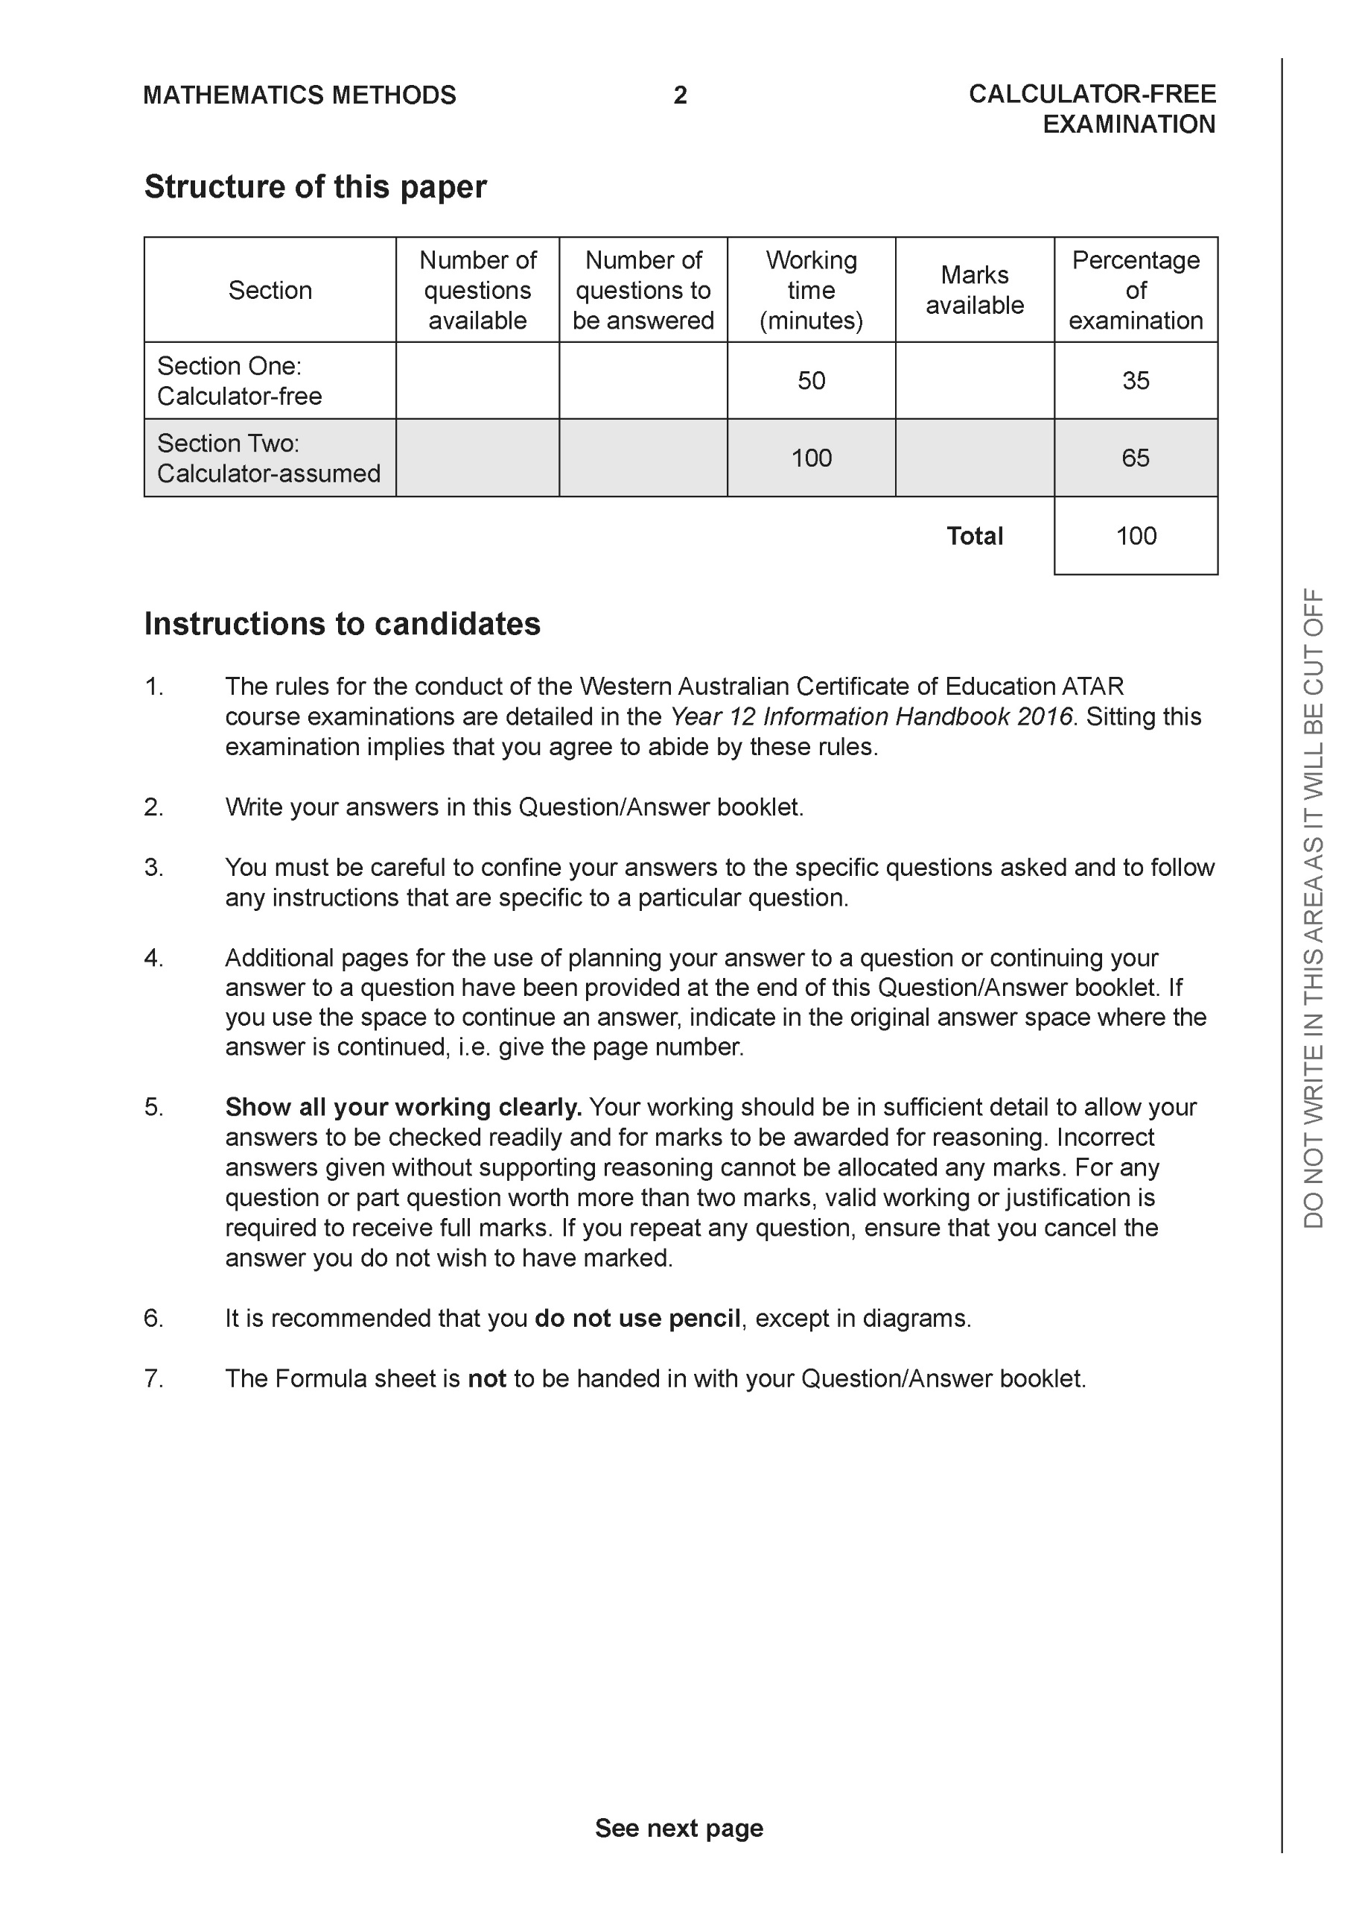

**Section One: Calculator-free (50 Marks)**

This section has **eight (8)** questions. Answer **all** questions. Write your answers in the spaces provided.

Spare pages are included at the end of this booklet. They can be used for planning your responses and/or as additional space if required to continue an answer.

● Planning: If you use the spare pages for planning, indicate this clearly at the top of the page.

● Continuing an answer: If you need to use the space to continue an answer, indicate in the original answer space where the answer is continued, i.e. give the page number. Fill in the number of the question that you are continuing to answer at the top of the page.

Working time: 50 minutes.

**Question 1 (6 marks)**

Consider the plane  which contains point A 

(a) Write a vector equation for this plane. (3 marks)

Consider the line 

(b) Determine the coordinates of where the line above meets the plane. (3 marks)

**Question 2 (6 marks)**

Sketch the graph  where . Clearly show the major features of the graph.

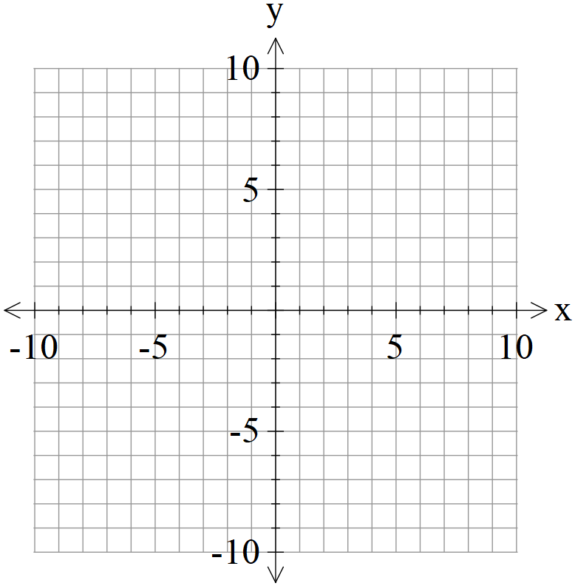

**Question 3 (6 marks)**

Consider the plane  that contains the following three points . Using vector methods, determine the distance of point  from the plane . Show all working and reasoning.

**Question 4 (5 marks)**

Consider the function  as graphed below.

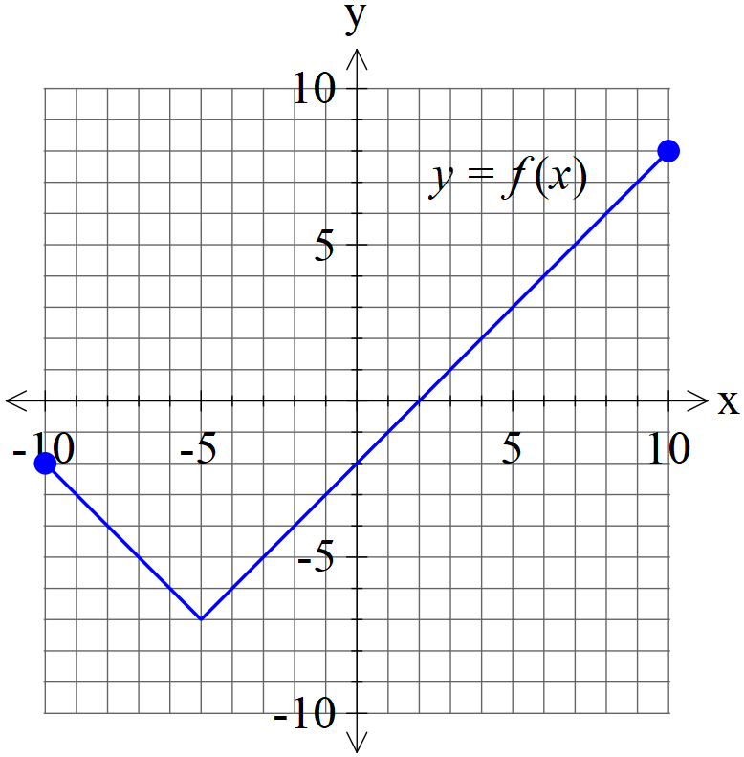

1. Graph  on the axes below. (2 marks)

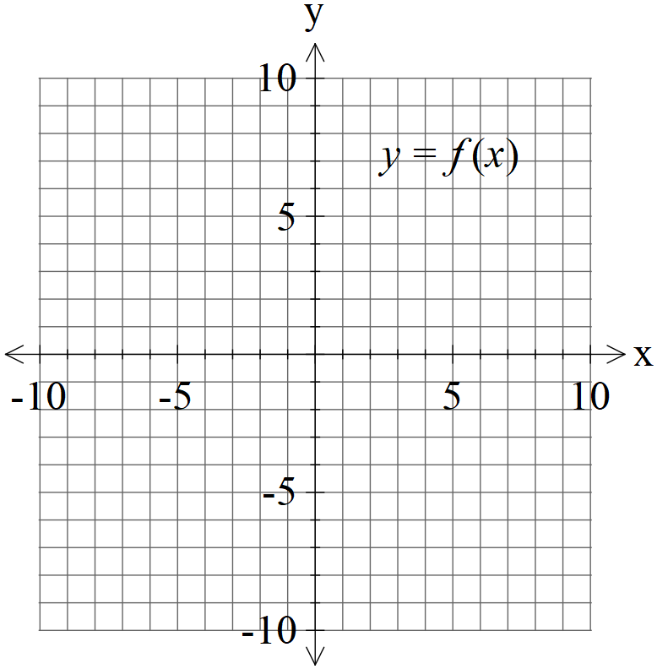

1. Graph  on the axes below. (3 marks)



**Question 5 (7 marks)**

Consider the function  with domain 

(a) Determine  and its domain. (4 marks)

(b) Consider  with  and  real constants. Given that  has an inverse which intersects graphically with  at one point only, determine a possible exact value for in terms of and an equation that must satisfy.

(3 marks)

**Question 6 (7 marks)**

Consider the following system of linear equations.



1. Solve for . (3 marks)

Q6 cont-

1. If we modify the equations to the following with  being constants, solve for the following values of such that there are:
2. no solutions
3. infinite solutions (Give a geometrical interpretation of this situation) (4 marks)



**Question 7 (10 marks)**

1. Solve for all solutions to the following  in the form  with .

(4 marks)

1. Plot the above roots on the diagram below, indicating scale. (3 marks)

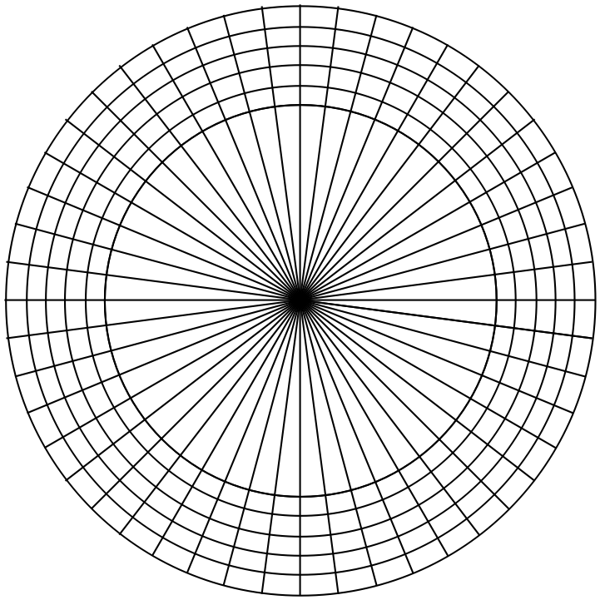

1. If these points are joined, forming a polygon, determine the exact area of this polygon.

(3 marks)

**Question 8 (3 marks)**

Sketch the locus of points that satisfy  on the complex plane below and explain your reasoning.

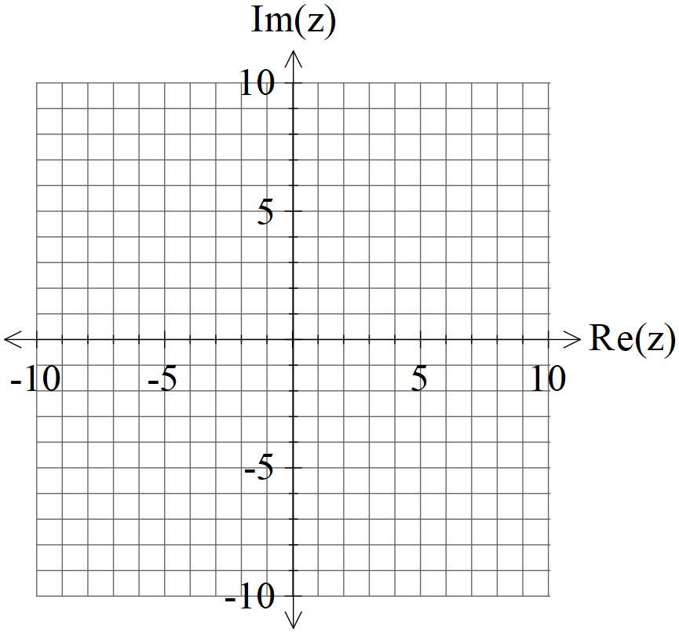

Additional working space

Question number:

Additional working space

Question number:

Additional working space

Question number:

**Acknowledgements**